Christmas Hymns
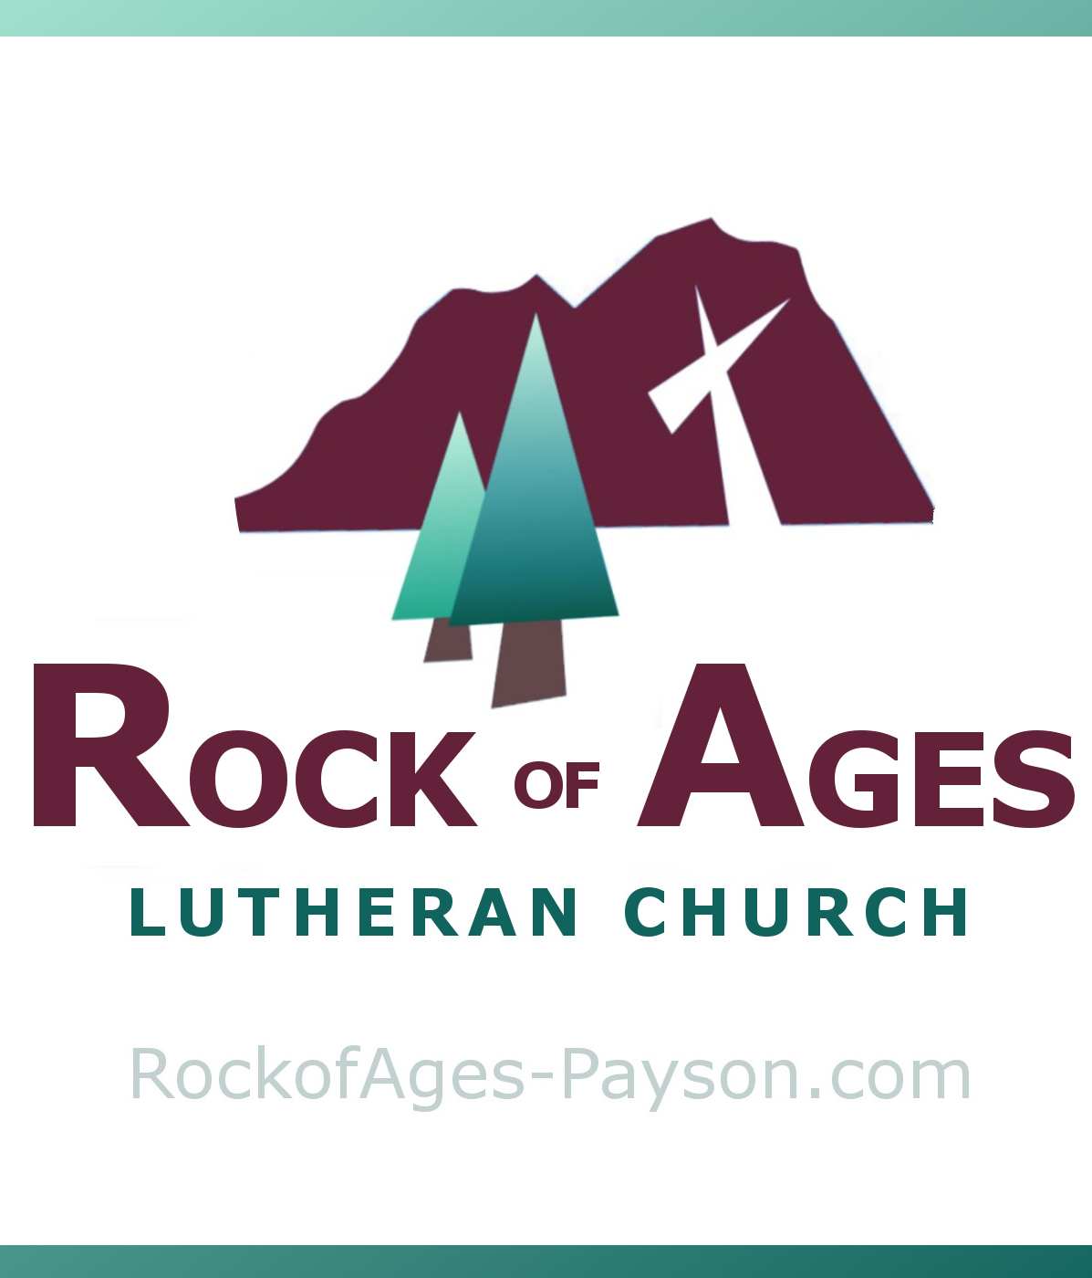
Caroling Booklet

All hymns are public domain.
You are welcome to keep this booklet.

Rock of Ages Lutheran Church
204 W. Airport Rd. Payson, AZ

Oh, Come All Ye Faithful
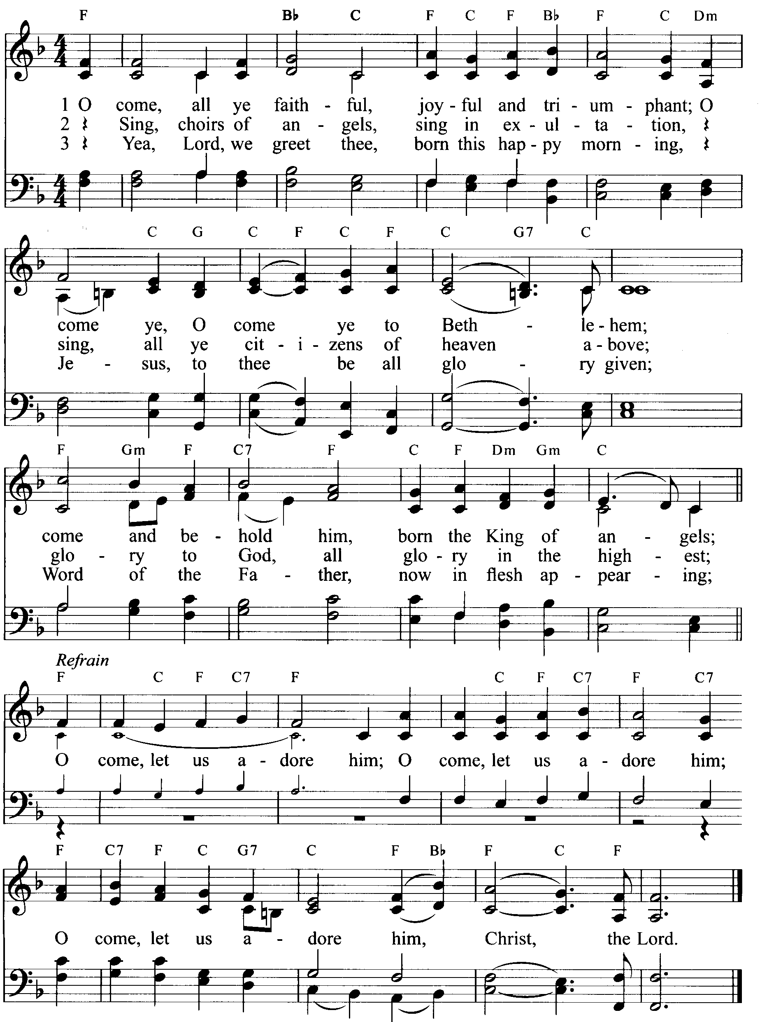

Away in a Manger
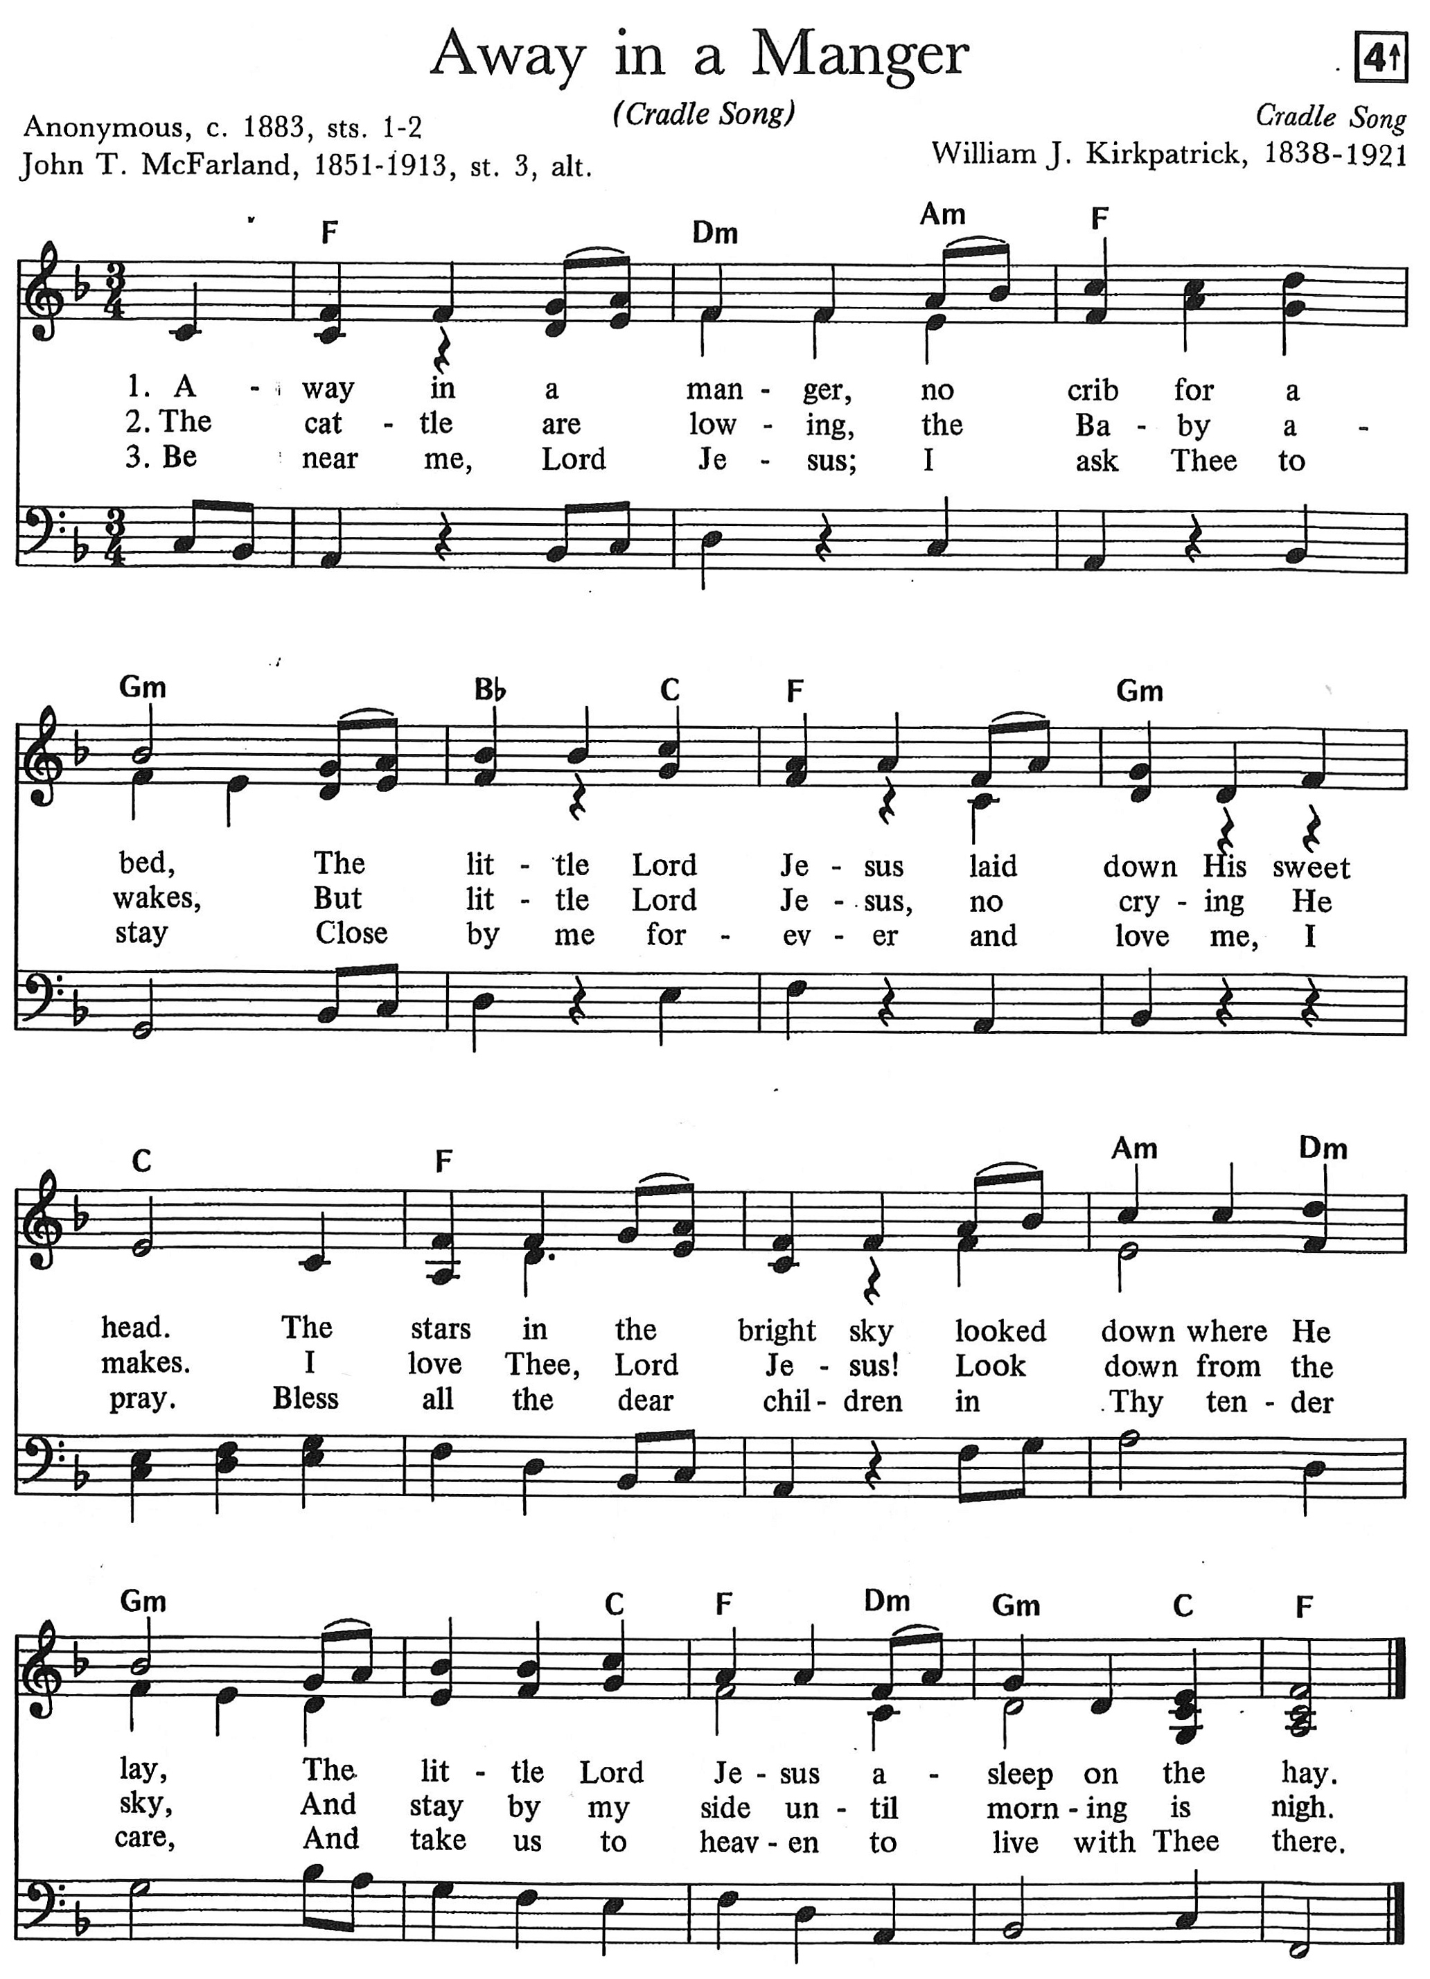

O Little Town of Bethlehem
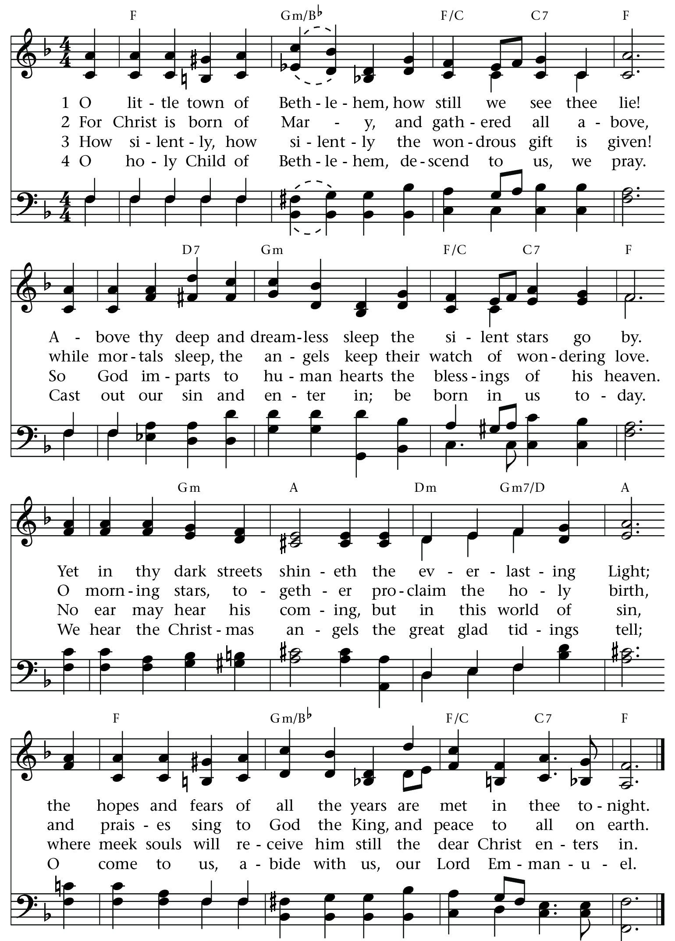
What Child is This
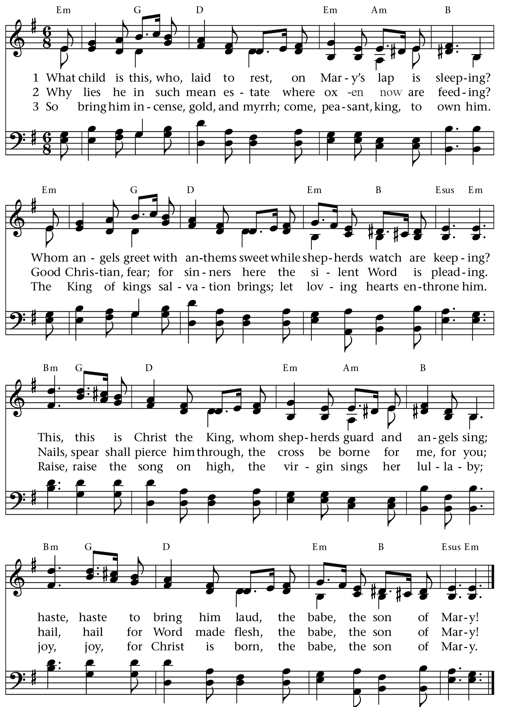
God Rest You Merry, Gentlemen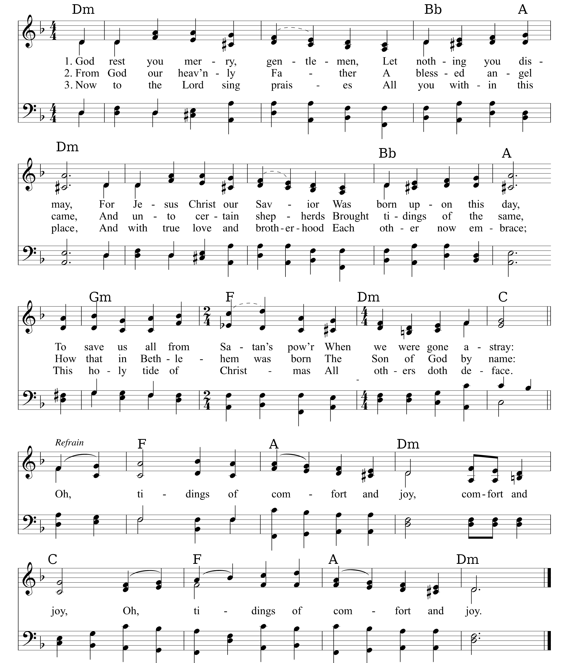

Hark! The Herald Angels Sing
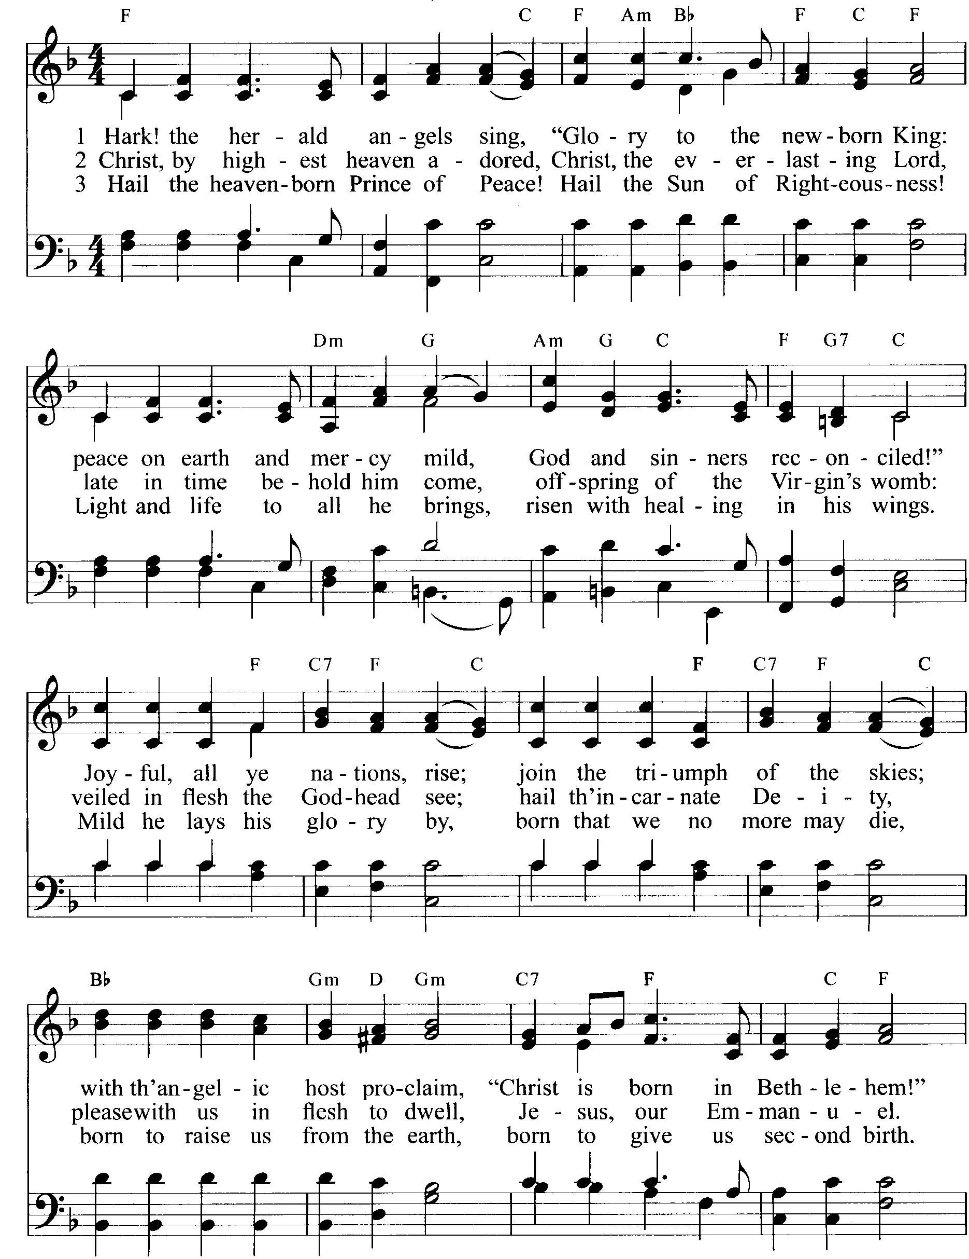after each stanza: ♫ Hark! the herald angels sing, “Glory to the new born King!”

Go Tell It On the Mountain
(guitar cap 2)
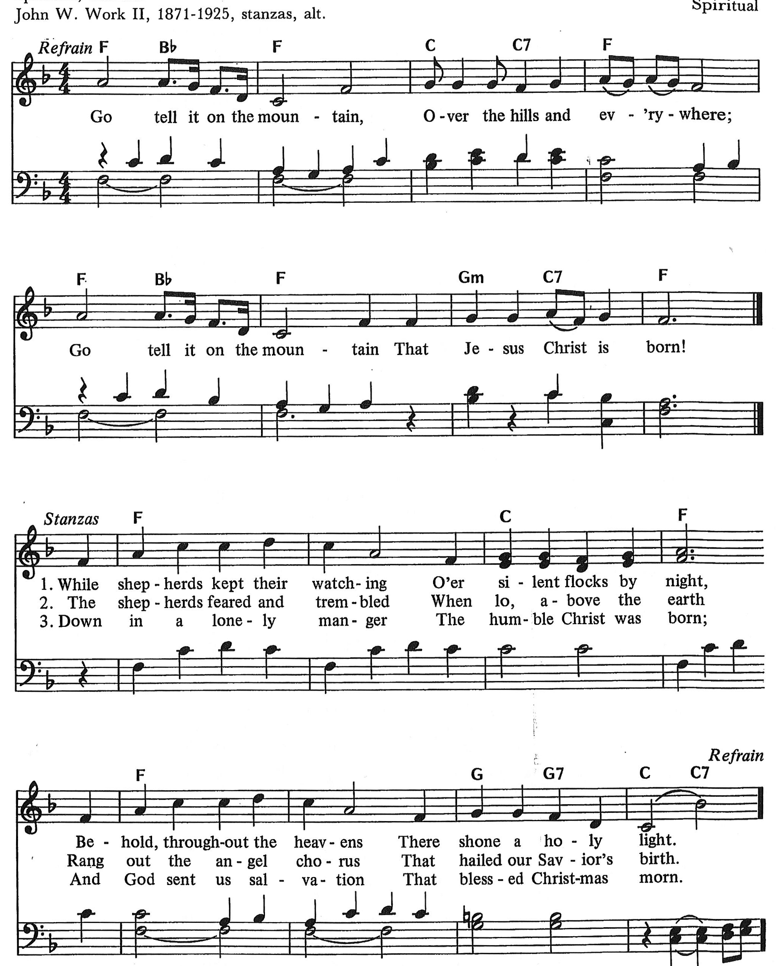

Silent Night
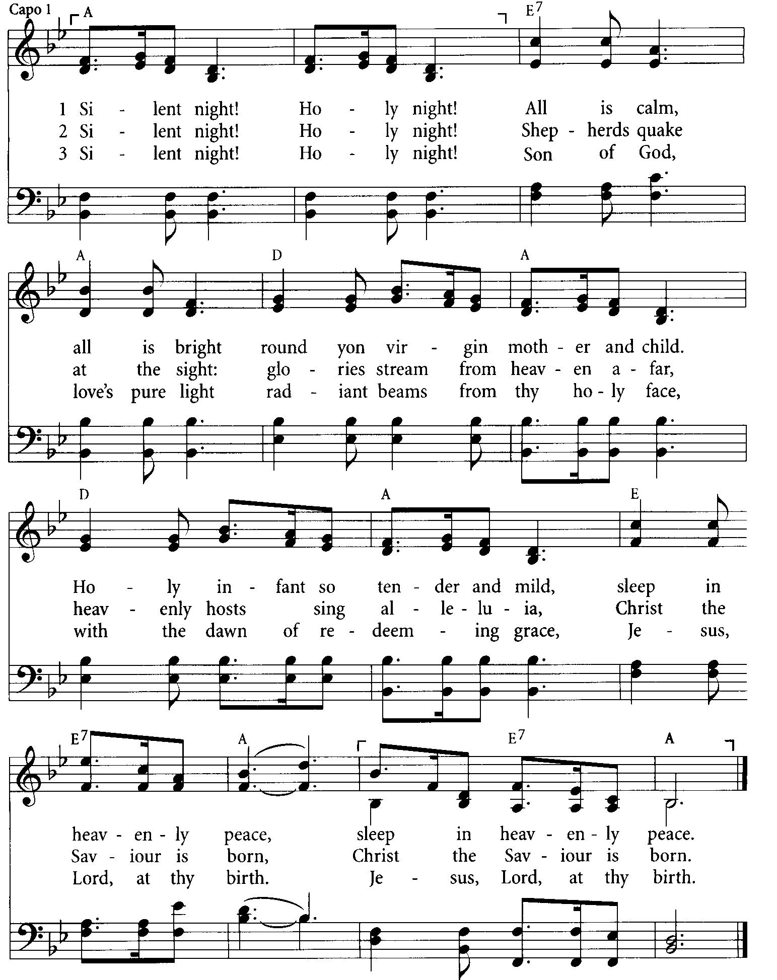

Angels We Have Heard On High
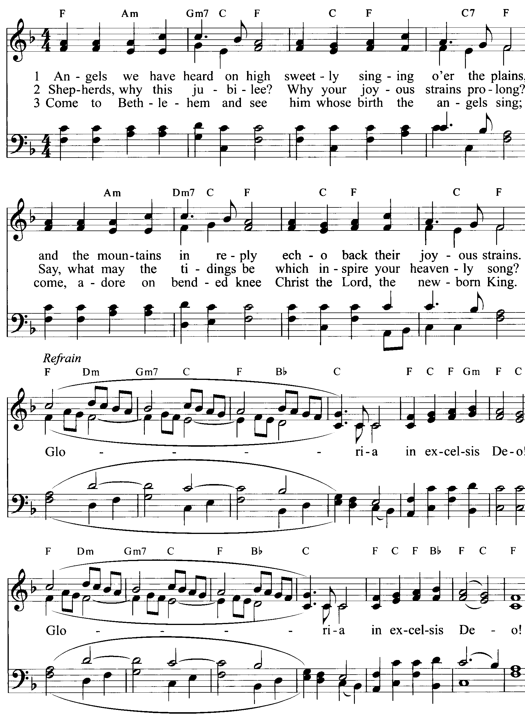
What the glad-some

Joy to the World
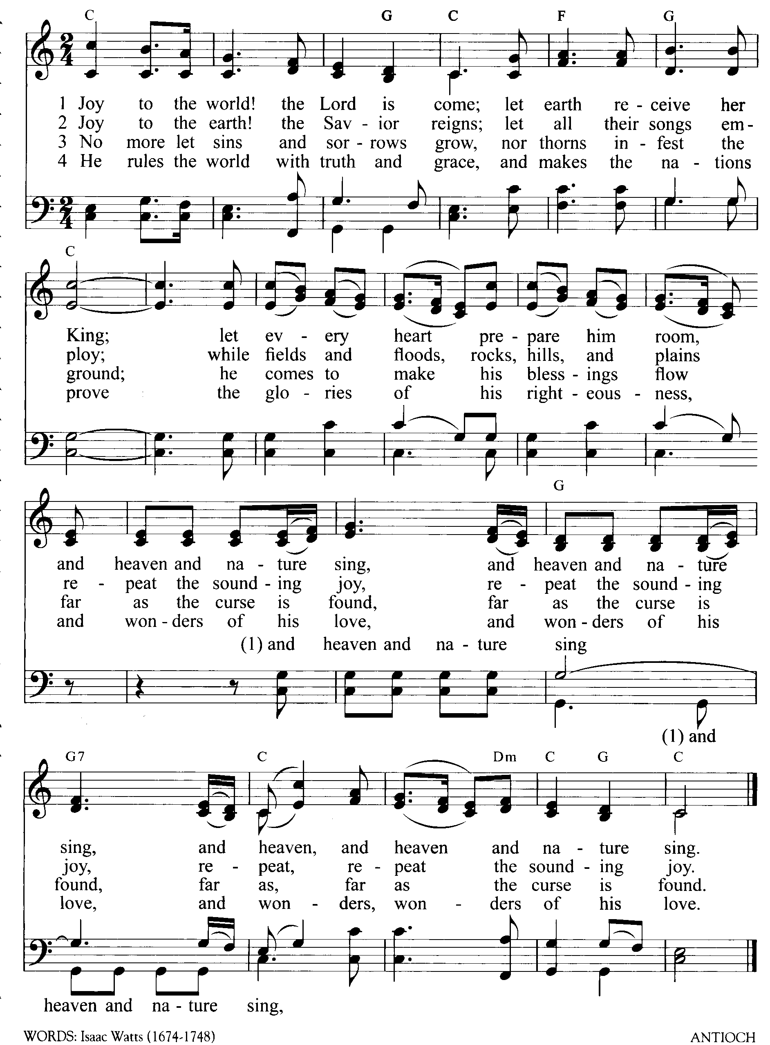

Contents
Oh, Come All Ye Faithful 2
Away in a Manger 3
O Little Town of Bethlehem 4
What Child is This 5
God Rest You Merry, Gentlemen 6
Hark! The Herald Angels Sing 7
Go Tell It On the Mountain 8
Silent Night 9
Angels We Have Heard On High 10
Joy to the World 11

Rock-solid hope in Jesus for Rim Country.

We’re located on the corner Airport Rd and McLane in Payson.

Our pastor is glad to visit with you to share God’s Word. Call 928-474-2098

Read and listen to Sunday sermons at RockOfAges-Payson.com

Worship
Sundays 9:00am

Christmas Eve 6:00pm
Christmas Day 9:00am

