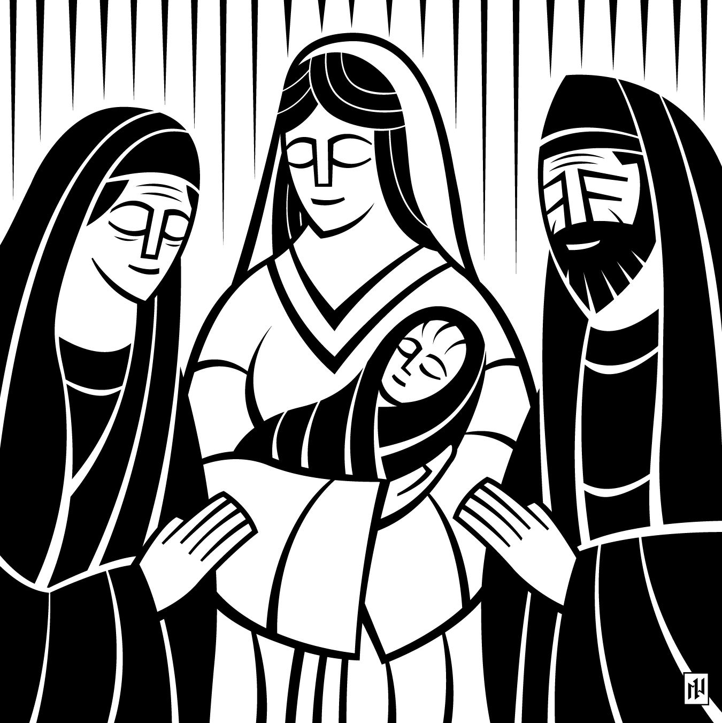
The Glory of the Lord
Is In His Temple

First Sunday after Christmas
9:00 & 11:15am December 27, 2020
Rock of Ages
Lutheran Church
Reaching Out in Rim Country with Rock-Solid Hope in Jesus
Welcome!
- May the message you hear today will fill your heart with the peace and joy we have in knowing that Jesus Christ is our Savior from sin.

- Our mission is to share the rock-solid hope of Jesus with today’s world through timeless truths found in the Holy Scriptures.

- Large print service folders and hearing assistance devices are available.

- Restrooms are located at the far ends of the entry area.

- Thank you for respecting your fellow worshippers by practicing social distancing. Volunteers are sanitizing the shared touch points between services.

- Children’s activity bags, quiet toys, and a changing table are available from the nursery in entry area.

- We are part of a world-wide Christian body and support the gospel ministry of the WELS. We’d love to share more with you. Contact our pastor today. You can also visit wels.net

Service of the Word & Sacrament
A version of the historic liturgy of the Christian church.

Hymn Love Has Come
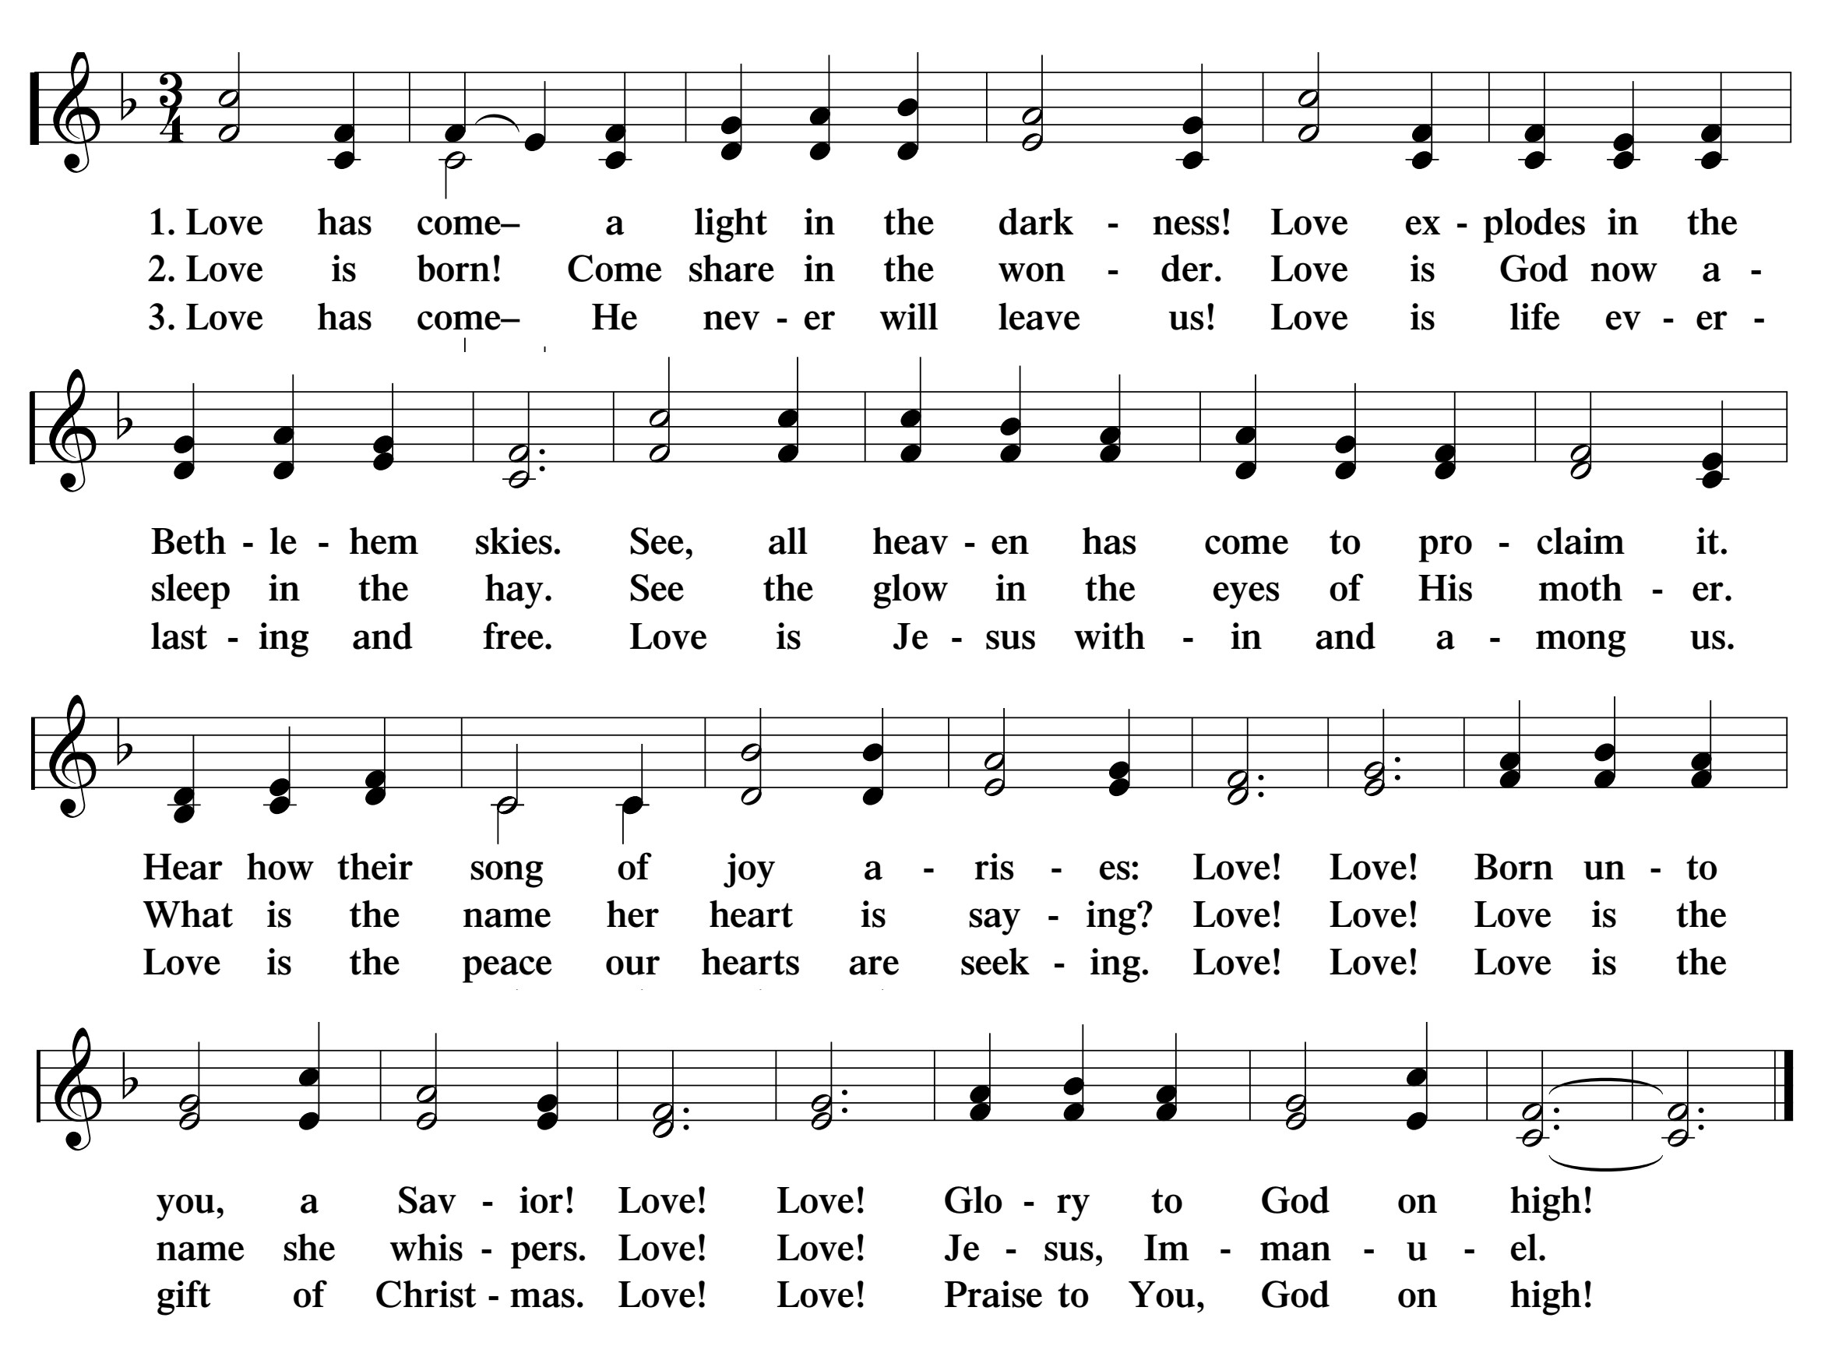

Greeting
The grace of our Lord † Jesus Christ and the love of God and the fellowship of the Holy Spirit be with you.
And also with you.

Confession of Sins
God invites us to come into his presence and worship him with humble and penitent hearts. Therefore, let us acknowledge our sinfulness and ask him to forgive us.
Holy and merciful Father, I confess that I am by nature sinful, and that I have disobeyed you in my thoughts, words, and actions. I have done what is evil and failed to do what is good. For this I deserve your punishment both now and in eternity. But I am truly sorry for my sins, and trusting in my Savior Jesus Christ, I pray: Lord, have mercy on me, a sinner.

God our heavenly Father, has been merciful to us and has given his only Son to be the atoning sacrifice for our sins. Therefore, as a called servant of Christ and by his authority, I forgive you all your sins in the name of the Father and the Son † and of the Holy Spirit.
Amen.

Lord Have Mercy Kyrie
For all that we need in life and for the wisdom to use all your gifts with gratitude and joy, hear our prayer, O Lord.
Lord, have mercy.

For the steadfast assurance that nothing can separate us from your love and for the courage to stand firm against the assaults of Satan and every evil, hear our prayer, O Christ.
Christ, have mercy.

For the well-being of your holy Church in all the world and for those who offer here their worship and praise, hear our prayer, O Lord.
Lord, have mercy.

Merciful God, maker and preserver of life, uphold us by your power and keep us in your tender care.
Amen.
The works of the Lord are great and glorious; his name is worthy of praise.

Response of Praise In His Temple Now Behold Him
Christian Worship 77
♫ In his temple now behold him; See the long-expected Lord.
Ancient prophets had foretold him; God has now fulfilled his Word.
Now to praise him, his redeemed Shall break forth with one accord.

2. In the arms of her who bore him, Virgin pure, behold him lie,
While his aged saints adore him Ere in faith and hope they die.
Alleluia! Alleluia! See th' incarnate God most high!

3. Jesus, by your presentation, You who did for us endure,
Let us see your great salvation, Seal us with your promise sure,
And present us in your glory To your Father, cleansed and pure.

Prayer of the Day

Almighty God, in mercy you sent your one and only Son to take upon himself our human nature. By his gracious coming deliver us from the corruption of our sin and transform us into the likeness of his glory; through Jesus Christ our Lord, who lives and reigns with you and the Holy Spirit, one God, now and forever.
Amen.

The Word
First Lesson 1 Kings 8:6-13
The Glory of the Lord filled the temple.
The priests brought the Ark of the Covenant of the Lord to its place in the inner sanctuary of the house, to the Most Holy Place, under the wings of the cherubim, ⁷for the cherubim were spreading their wings over the place for the ark, so that the cherubim covered the ark and its poles with their wings. ⁸The poles were so long that the ends of the poles could be seen from the Holy Place in front of the inner sanctuary, but they could not be seen from outside. They are there to this day.
⁹There was nothing in the ark except the two stone tablets, which Moses had placed there at Horeb, where the Lord made a covenant with the people of Israel when they came out of the land of Egypt.
¹⁰When the priests came out from the Holy Place, the cloud filled the House of the Lord. ¹¹The priests were not able to take their positions to minister in the presence of the cloud, because the Glory of the Lord had filled the House of the Lord.
¹²Then Solomon said, “The Lord has said that he dwells in thick darkness. ¹³I have truly built a majestic house for you, a place for you to dwell forever.”

Psalm of the Day Psalm 30
Christian Worship page 76

♫ At the works of your hands, O Lord, I lift up my voice in song, I sing for joy.
Sing to the Lord, you saints of his;
praise his holy name.

For his anger lasts only a moment,
but his favor lasts a lifetime;

weeping may remain for a night,
but rejoicing comes in the morning. Refrain

To you, O Lord, I called;
to the Lord I cried for mercy:

“Hear, O Lord, and be merciful to me;
O Lord, be my help.”

You turned my wailing into dancing,
that my heart may sing to you and not be silent.

Glory be to the Father and to the Son
and to the Holy Spirit,
as it was in the beginning,
is now, and will be forever. Amen. Refrain
Second Lesson Colossians 3:12-17
As God’s temple we are filled with his Word and his peace.
Therefore, as God’s elect, holy and loved, clothe yourselves with heartfelt compassion, kindness, humility, gentleness, and patience. ¹³Bear with one another and forgive each other if anyone has a complaint against anyone else. Forgive, just as Christ forgave you. ¹⁴And, in addition to all these things, put on love, which ties things together in perfect unity. ¹⁵Let the peace of Christ control your hearts, to which you were also called, in one body. And be thankful.
¹⁶Let the word of Christ dwell in you richly, as you teach and admonish one another with all wisdom, singing psalms, hymns, and spiritual songs, with gratitude in your hearts to God. ¹⁷And everything you do, whether in word or deed, do it all in the name of the Lord Jesus, giving thanks to God the Father through him.
Verse of the Day (Colossians 3:15a)
Alleluia. Let the peace of Christ rule in your hearts. Alleluia

Carol Wexford Carol
Sung by 4 For Christ

Gospel Luke 2:25-40
The Son of God incarnate shines in glory in his temple.
Now there was a man in Jerusalem whose name was Simeon. This man was righteous and devout, waiting for the comfort of Israel, and the Holy Spirit was on him. ²⁶It had been revealed to him by the Holy Spirit that he would not see death before he had seen the Lord’s Christ. ²⁷Moved by the Spirit he went into the temple courts. When the parents brought in the child Jesus to do for him what was customary according to the law, ²⁸Simeon took him into his arms and praised God. He said,
²⁹Lord, you now dismiss your servant in peace, according to your word,
³⁰because my eyes have seen your salvation,
³¹which you have prepared before the face of all people,
³²a light for revelation to the Gentiles, and the glory of your people Israel.

³³Joseph and the child’s mother were amazed at the things that were spoken about him. ³⁴Then Simeon blessed them and said to Mary his mother, “Listen carefully, this child is appointed for the falling and rising of many in Israel and for a sign that is spoken against, ³⁵so that the thoughts of many hearts may be revealed. And a sword will pierce your own soul too.”
³⁶Anna, a prophetess, was there. She was a daughter of Phanuel, of the tribe of Asher. She was very old. She had lived with her husband for seven years after her marriage, ³⁷and then she was a widow of eighty-four years. She did not leave the temple complex, since she was worshipping with fasting and prayers night and day. ³⁸Standing nearby at that very hour, she gave thanks to the Lord. She kept speaking about the child to all who were waiting for the redemption of Jerusalem.
³⁹When they had accomplished everything according to the law of the Lord, they returned to Galilee, to their own town, Nazareth. ⁴⁰The child grew and became strong. He was filled with wisdom, and God’s favor was on him.
After the reading:
These are the words and works of our King!
Praise be to you, O Christ!

Hymn of the Day From Heaven Above to Earth I Come
Christian Worship 38
Selected stanzas
♫ "From heav'n above to earth I come
To bear good news to ev'ry home;
Glad tidings of great joy I bring,
Whereof I now will say and sing:

3. "This is the Christ, our God most high,
Who hears your sad and bitter cry;
He will himself your Savior be
From all your sins to set you free.

4. "He will on you the gifts bestow Prepared by God for all below,
That in his kingdom, bright and fair, You may with us his glory share.

9.Ah, Lord, though you created all, How weak you are, so poor and small,
That you should choose to lay your head Where lowly cattle lately fed!

10.Were earth a thousand times as fair And set with gold and jewels rare,
It would be far too poor and small A cradle for the Lord of all.

12. And so it pleases you to see This simple truth revealed to me:
That all the world's wealth, honor, might Are weak and worthless in your sight.

13. Ah, dearest Jesus, holy Child, Prepare a bed, soft, undefiled
Within my heart, made clean and new, A quiet chamber kept for you.

14. My heart for very joy must leap; My lips no more can silence keep.
I, too, must sing with joyful tongue That sweetest ancient cradle song:

15. Glory to God in highest heaven, Who unto us his Son has given!
While angels sing with pious mirth A glad new year to all the earth.

Sermon 1 Kings 8:6-13
The Glory of the Lord is in His Temple Now

Confession of Faith Te Deum Laudamus for Christmas
We praise you, O God, we acclaim you as Lord; all creation worships you, Father everlasting. (CW 64)
♫ Let us all with gladsome voice
Praise the God of heav'n,
Who, to bid our hearts rejoice,
His own Son has giv'n.

To this vale of tears he comes,
Here to serve in sadness,
That with him in heav'n's fair homes
We may reign in gladness.

To you all angels, all the powers of heaven, cherubim and seraphim, sing in endless praise: Holy, holy, holy Lord, God of heavenly hosts, heaven and earth are full of your glory. (CW 80)
♫ Angels from the realms of glory,
Wing your flight o’er all the earth;
Once you sang creation’s story;
Now proclaim Messiah’s birth:
Come and worship, come and worship,
Worship Christ, the new-born King.

All creation, join in praising
God the Father, Spirit, Son,
Evermore your voices raising,
To the eternal Three in One:
Come and worship, come and worship,
Worship Christ, the new-born King.

The glorious company of apostles praise you. The noble fellowship of prophets praise you. The white robed army of martyrs praise you. Throughout the world the holy Church acclaims you: Father of majesty unbounded, your glorious, true, and only Son, and the Holy Spirit, advocate and guide. (CW 28)
♫ Let the earth now praise the Lord, Who has truly kept his word
And at last to us did send Christ, the sinner’s help and friend.

What the fathers most desired, What the prophets’ heart inspired,
What they longed for many a year Stands fulfilled in glory here.

You, Christ, are the King of glory, the eternal Son of the Father. (CW 61)
♫ Hark! The herald angels sing, "Glory to the newborn King;
Peace on earth and mercy mild, God and sinners reconciled!"
Joyful, all you nations rise, Join the triumph of the skies;
With th' angelic host proclaim, "Christ is born in Bethlehem!"
Hark! The herald angels sing, "Glory to the newborn King!"

When you became man to set us free, you humbled yourself to be born of a virgin. You overcame the sting of death and opened the kingdom of heaven to all believers.
(CW 56)
♫ Gentle Mary laid her child Lowly in a manger;
There he lay, the undefiled, To the world a stranger.
Such a babe in such a place—
Can he be the Savior? Ask the saved of all the race
Who have found his favor.

Gentle Mary laid her child Lowly in a manger;
There he lay, the undefiled, But no more a stranger.
Son of God, of humble birth, Beautiful the story;
Praise his name in all the earth,
Hail the King of glory!

You sit at the right hand of God in the glory of the Father. We believe that you will come to be our judge. Come then, Lord, and help your people, bought with the price of your own blood, and bring us with your saints to glory everlasting.
(CW 50)
♫ But our eyes at last shall see him
Through his own redeeming love,
For that child, so dear and gentle,
Is our Lord in heav'n above,
And he leads his children on
To the place where he is gone.

Not in that poor, lowly stable
With the oxen standing by
Shall we see him, but in heaven,
Set at God's right hand on high.
Then like stars his children crowned,
All in white, his praise will sound.

Offerings
Moved by God’s love in Christ, we offer him our first and best gifts, purely out of thanks to him. Our offerings go to support the gospel ministry of our congregation and our church body, the Wisconsin Evangelical Lutheran Synod. Today the offerings can be placed on the table as you enter or exit.

Prayer of the Church Christian Worship Page 32
Gracious God and Father, we praise you for the countless blessings, which we receive from your hand: the beauties of creation and the bounties of the earth, the joy of life and the pleasure of friendship, the good of work and the gift of rest, the privilege to share happiness and sorrow with one another. Above all we praise and thank you for your saving Word and for your Son’s body and blood, which you give us to eat and to drink in the sacrament. Through these means of grace, you send the Holy Spirit into our hearts and unite us to Jesus and to the whole Christian Church on earth.
Strengthen us through this heavenly food; increase our trust in Christ and our love for one another.

Great God and Lord, without your continuing help we easily waver in our faith, lose courage, and grow careless in our watchfulness. The times and days are perilous. Give us strength to face the evils of each day with fresh confidence. Open our lips to speak of your grace, and move us to use the gifts that you give us to share your Word of salvation with all people. Protect and prosper the family, the school, the government, and all good institutions that you have established for the benefit of society. Remember in mercy those who are sick and suffering, and bring your healing to troubled homes and lives.
Move us to pray for those in need and to help them with deeds of kindness.
Special prayers and intercessions may follow.
Hear us, Lord, as we bring you our private petitions. (Silent prayer)

Now, eternal God and Father, keep us in the saving faith and so enable us to overcome all things through our Lord Jesus Christ.

Lord’s Prayer (Matthew 6:9-13)
Our Father, who art in heaven, hallowed be thy name, thy kingdom come, thy will be done on earth as it is in heaven. Give us this day our daily bread; and forgive us our trespasses, as we forgive those who trespass against us; and lead us not into temptation, but deliver us from evil. For thine is the kingdom and the power and the glory forever and ever. Amen.

The Sacrament
Our Lord Jesus has given us a holy supper in which we receive his true body and blood for the forgiveness of sins and the strengthening of our faith. In this supper we celebrate the gift of his redemption, we bear witness to the fellowship we share as confessors of the truth, and we proclaim his death until he comes.

The Lord be with you.
And also with you.

Lift up your hearts
We lift them up to the Lord.

Let us give thanks to the Lord our God.
It is right to give him thanks and praise.

Praise be to the God and Father of our Lord and Savior Jesus Christ! In love he has blessed us with every spiritual blessing. When the time had fully come, he sent his Son, born of a woman, born under law, to redeem those under law, that we might receive the full rights of sons. To him who sits on the throne and to the Lamb be praise and thanks and honor and glory forever and ever.

Holy, Holy, Holy Sanctus ”Joy to the World”

♫ Joy to the world, the Lord is come! Let earth receive her King;
Let ev'ry heart prepare him room And heav'n and nature sing,
And heav'n and nature sing, And heav'n, and heav'n and nature sing.

Our Lord Jesus Christ, on the night he was betrayed, took bread; and when he had given thanks, he broke it and gave it to his disciples, saying, “Take and eat; this is my body, which is given for you. Do this in remembrance of me.” Then he took the cup, gave thanks, and gave it to them, saying, “Drink from it, all of you; this is my blood of the new covenant, which is poured out for you for the forgiveness of sins. Do this, whenever you drink it, in remembrance of me.” The peace of the Lord be with you always.
Amen.

O Christ, Lamb of God Agnus Dei “What Child Is This”

♫ Why lies he in such mean estate Where oxen now are feeding?
Good Christians, fear; For sinners here The silent Word is pleading.
Nails, spear shall pierce him through; The cross he'll bear for me, for you.
Hail, hail the Word made flesh, The babe, the Son of Mary!

Distribution
Members Rock of Ages Lutheran and all who publicly share in our church body’s (WELS) fellowship are invited to come forward as directed. If you are interested in learning more about what we teach and becoming a member at Rock of Ages, please speak with our pastor after today’s service.

Song of Simeon Nunc Dimittis (spoken) Luke 2:29-32
Lord, you now dismiss your servant in peace, according to your word, because my eyes have seen your salvation, which you have prepared before the face of all people, a light for revelation to the Gentiles, and the glory of your people Israel.

Prayer and Blessing
Hear the prayer of your people, Lord, that the lips which have praised you here may glorify you in the world and that the eyes which have seen the coming of your Son may long for his coming again.
Amen.

Brothers and sisters, go in peace. Live in harmony with one another. Serve the Lord with gladness. The Lord bless you and keep you. The Lord make his face shine on you and be gracious to you. The Lord look on you with favor and give you peace.
Amen.

Hymn Father, Let Me Dedicate
Christian Worship 75
♫ Father, let me dedicate
All this year to you,
In whate'er my earthly state,
In whate'er I do.
Not from sorrow, pain, or care
Freedom dare I claim;
This alone shall be my prayer:
Glorify your name.

2. Can a child presume to choose Where or how to live?
Can a father's love refuse All the best to give?
More you give me ev'ry day Than the best can claim;
Help me trust you that I may Glorify your name.

3. If in mercy you prolong Joys that now are mine,
If on life serene and fair Brighter rays may shine,
Let my glad heart, while it sings, You in all proclaim
And, whate'er the future brings, Glorify your name.

4. If you have for me a cross And its shadow come,
Turning all my gain to loss, Shrouding heart and home,
Let me think how your dear Son To his glory came
And in deepest woe pray on: "Glorify your name."

NEWS & ANNOUNCEMENTS  Remember with Prayer  - Tatum, granddaughter of Tom and Sandy Spielberg; that God provide her with strength during her prolonged severe illness and give her peace and healing.  - Mary Strong; that God bless her heart procedure planned for Jan 4th.  - Doris, great-granddaughter of Doris Strickland; thanks to God for answering prayers and giving her stable health from the seizure disorder.  - Brian, son of Pat Solomon, that God give him a full recovery from Covid-19.  - Thanks to God for the full recovery of Ellie Krigbaum and her son Wyatt.  Attendance  12/16 Midweek Advent: 25  12/17 Starting Point Class: 2  12/20 Sunday Worship: 57  12/20 Sunday Bible Class: 22  12/20 Confirmation Class: 2  Received in December $7,239.32 (as of Dec 14th)  Serving This Week  Flowers, Communion Setup: Marsha Wente  Music: Keyboard, Jeni Strickland; 4 For Christ  Presiding Minister: Tom Barthel  Ushers: Creig Solomon, Jerry Zuvich  Acknowledgments  Inside artwork © 2011 Ian Welch paramentics.com  Oder of Service adapted from “Service of Word and Sacrament” © Northwestern Pub. House.  Scripture taken from The Holy Bible, Evangelical Heritage Version®, EHV®, © 2019 Wartburg Project, Inc. All rights reserved.  The following service items are printed under CCLI #2524351 or Onelicense.net #A 716430 all rights reserved, used by permission. All other music is public domain.  “Love Has Come” words: Ken Bible © 1996 Integrity's Hosanna! Music | CALENDAR  rockofages-payson.com/calendar  Sunday, December 27 Christmas 1  9:00am Service with Lord's Supper  10:05am Bible Study  11:15am Service with Lord's Supper  12:30pm Youth Confirmation Class  Wednesday, December 30  6:00pm Midweek Bible Class  Thursday, December 31 New Year's Eve  9:00am Midweek Bible Class  10:00am Starting Point Class  Friday, January 1, 2021 New Year's Day  9:00am New Year's Day Worship  Sunday, January 3, 2021 Christmas 2  9:00am Service  10:05am Bible Study  11:15am Service  12:30pm Youth Confirmation Class  Tuesday, January 5, 2021  9:00am Christmas Decoration Take Down  Wednesday, January 6, 2021 Epiphany  9:00am Elders Meeting  Thursday, January 7, 2021  9:00am Circuit meeting at Cornville  204 W. Airport Rd. Payson, AZ 85541 ● Office: 928-474-2098 ● pastorbarthel@gmail.com  Pastor Tom Barthel ● Mobile: 928-612-8463

